Newport Junior
Football League
NEWSLETTER MAY 2021

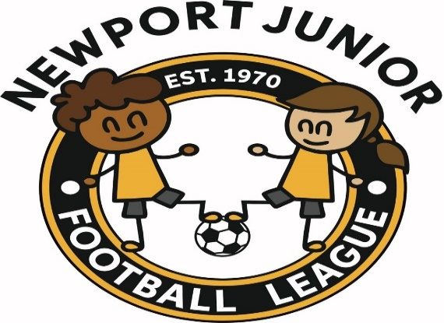

END OF SEASON
Well that is the end of the shall we say the season that never happened and without a doubt it will go down in history.

It has been an extremely difficult season for lots of us in many ways. We have kept our Executive meetings going but as you can imagine they have not been as long as normal. We have tried to keep football going as much as possible within the guidelines.

Even before this season ended, we have been working towards and making plans for next season. Some items I can tell you about in this newsletter.

ANNUAL GENERAL MEETING
This years Annual General Meeting will once again be held via Zoom. The date of the meeting is 8th June 2021 to commence at 6.30 p.m. I will send out invites to all a week before the meeting. Please find attached the minutes from last years meeting.

UNDER 13’S SEASON 2021/2022
We can confirm that the under 13’s for the forthcoming season will be playing 11 v 11. Discussions with all clubs will need to take place to what happens for the season 2022/2023.

UNDER 12’S
At U12s if a team has one child still in primary school or playing one year "up" to U12 then that team, as per FAW rules, cannot play any competitive football.

Therefore, we are looking to join with Monmouthshire League. Newport will run an under 12’s non competitive league and Monmouthshire will run an under 12’s competitive league.

MONMOUTHSHIRE & NEWPORT
We are once again merging with our friends in Monmouthshire as we have done for the past few years for our other age groups. Newport will run the under 13’s and 15’s leagues with Monmouthshire running under 14’s & 16’s leagues.

START OF SEASON
Consideration is currently being given to starting the 2021/22 season early - 14th or 21st August currently being considered. Flexibility will be key as we are aware some teams have numbers of players still engaged in other sports at this time. Nothing is decided - your views would be welcome.

FEES
At a recent meeting that I attended the matter of registration fees to the FAW was discussed and voted upon. The majority were all in favour of no charges for registration fees for the season 2021/2022. This has not been passed by the FAW as yet but we are confident that this will be the case.

Fees to the league will be discussed at a later date.

50th CELEBRATION DINNER
We are still trying to arrange our celebration dinner which was cancelled last May 2020 and then again May 2021. We are hoping to hold the dinner on 25th September 2021. Of course, we will have to abide by any guidelines that will be in force.

RETURN TO PLAY
You have all received guidance on return to play. Please ensure that this information is passed to all your managers and all abide by the rules of the Welsh Assembly.

Although on times they do seem strict it is still all about saving all our lives. Corona virus has not gone away.

FRIENDLY GAMES
Instructions from Gwent County re friendly games. Clubs in the same League, both clubs should get sanction from their League Secretary.
When playing a friendly against a team from a different League, both clubs must get sanction from their League and this Association.
No sanction will be given for any club that owes outstanding fees to the FAW, Gwent County or this League.
NEWPORT CITY COUNCIL
We have been advised from the above that they are not taking any bookings for pitches after 30/04/2021. This is due to work that needs to be carried out on all pitches.
COMET REGISTRATIONS
We believe that registrations on COMET will reopen form 9th June 2021. This information has already been sent to all clubs and is on the FAW website.

WEB SITE
Go and have a look at our web site and please fill in the sheet on the contacts page with any comments that you may have. www.ndjyfl.com

We have now created a link for sponsorship on our web site. If you know of anyone who would like to advertise on our site please let us know.

STAY SAFE

Secretaries please ensure that this Newsletter is distributed to all at your club including committee members

Managers – please show these Newsletters to your parents or direct them to our website

