Newport Junior
Football League
NEWSLETTER JULY 2021

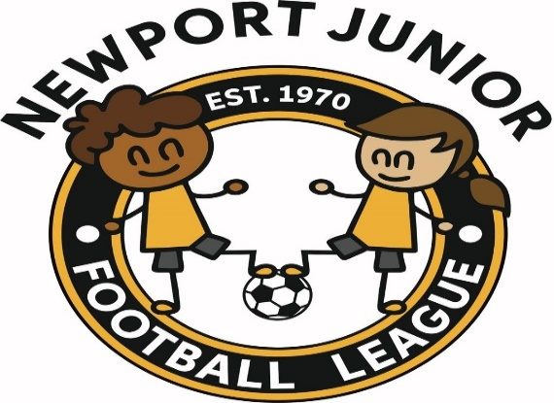

FEES
There will be no fees for any player to pay to the Newport League for the season 2021/2022.

GRANT
We have received a grant from Gwent County. Some of which we have used to pay for pitches etc. We are now looking to spend the rest of the grant on helping new under 7’s coaches attend a Football Leaders Award.

All coaches will need to book the course via Welsh Football Trust Coach Education in the usual way and make the payment. A receipt is issued for your payment. Club secretaires to forward a copy of the receipt, name of coach and date they are attending the course to myself. Please note if a coach does not attend the course no refund will be given by the league.

There is a cut-off date of 24/10/2021 to send in this information to the league. The league will look to cover as much of the costs as possible. The grant is not huge so it will depend on funds on what is returned to clubs.

MINI TEAMS
We now require you to tell us what age group and how many mini teams you wish to enter for the 2021/2022 season. The closing date for entry’s will be 8th August 2021. No teams will be accepted after this date until January 2022 when fixtures for the second half of the season will be produced. If you withdraw teams after the 8th August 2021, you will be charged as per rule.

Please return all mini-information to myself not David Bird.

COMPETITIVE TEAM ENTRIES
On 29th June an e mail was sent to all clubs advising that all U13 and U15 team entries had to be entered on COMET Competitions by COB on 1st August. A link to the entry pages was supplied. As 22 July only 12 of the forecast 20 x U13 teams and 9 of the forecast 14 x U15 teams had been entered. Be aware, 1st August date is an absolute deadline - there will be no late submissions accepted irrespective of any reason.

The same situation also applies to the U12 Competitive, U14 and U16 competitions run by the Monmouthshire League. Their deadline is also 1st August.

The U12 Non competitive League is now on COMET and teams can be entered on there as well.

ROSTERS
COMET Competitions gives team managers/clubs the ability to create "rosters" for teams. This is a requirement for entry into our U13 and U15 league and cup competitions. Doing this limits teams to selecting players in their "roster" thereby preventing players from playing for more than 1 team and making them compliant with FAW rules on "one player, one team".

COMET COMPETITIONS TRAINING
An e mail has been sent out to Club COMET users with a "training" guide. This has been sent out by FAW. We are unaware of any scheduled training webinars for club users being set up. Our own experience of the "training" for Leagues is not good so we would strongly advise you to go through the 50+ slides very closely. Remember this is NOT our system. It is FAW imposed. If it causes any confusion or extra work do not blame the League.
We would ask however that you keep a list of all things wrong with COMET. We as a league have started to do this. We cannot go back to the FAW and say it is not suitable for us without evidence. Se please start keeping lists and you can send them to me to collate in October.

50th CELEBRATION DINNER
We are still trying to arrange our celebration dinner which was cancelled last May 2020 and then again May 2021. We are hoping to hold the dinner on 25th September 2021. Of course, we will have to abide by any guidelines that will be in force.

FRIENDLY GAMES
I have added this again as some clubs still seem confused about what they need to do.

Instructions from Gwent County re friendly games. Clubs in the same league - both clubs should get sanction from their League Secretary.
When playing a friendly against a team from a different League - both clubs must get sanction from their League and this Association.
No sanction will be given for any club that owes outstanding fees to the FAW, Gwent County this league or if have any clubs have not affiliated to GC.

WEB SITE
Go and have a look at our web site and please fill in the sheet on the contacts page with any comments that you may have. www.ndjyfl.com

We have now created a link for sponsorship on our web site. If you know of anyone who would like to advertise on our site please let us know.

STAY SAFE

Secretaries please ensure that this Newsletter is distributed to all at your club including committee members

Managers – please show these Newsletters to your parents or direct them to our website

